**Task 1** – Create a user with your last name and give it admin access equivalent to ROOT user.

Creating a user, providing a password and verifying:

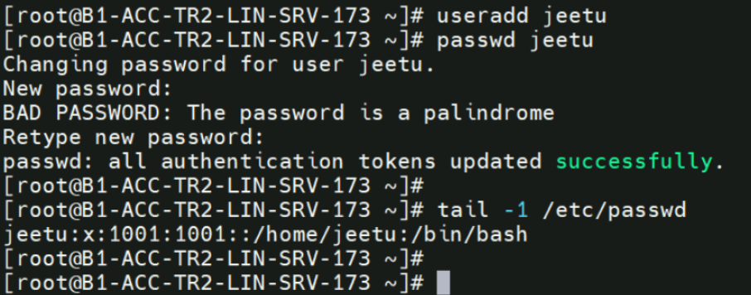

Providing the root equivalent access (using command “visudo”):



Go to line 100, and add your user entry like given below:

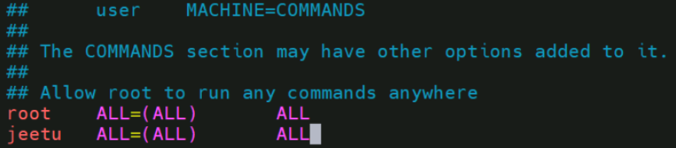

Login to the “jeetu” user and list the sudo access:

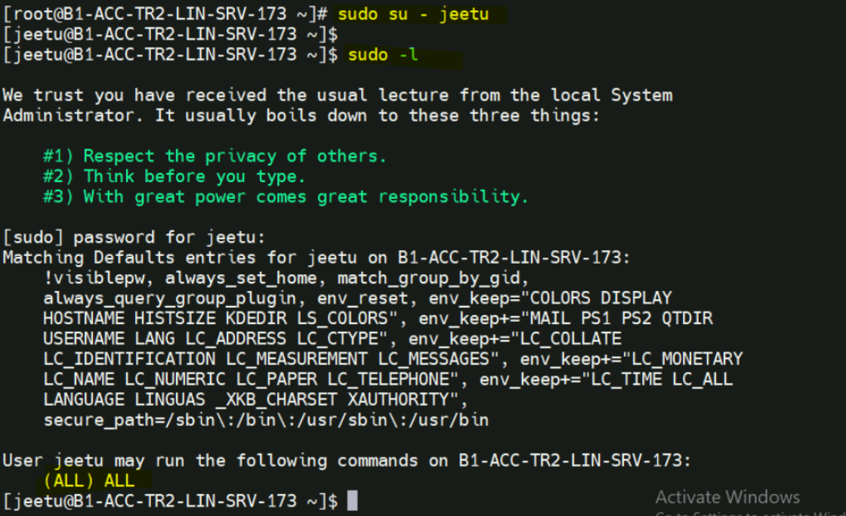

**Task 2** - create a user with the following details in a single (useradd command)

* username : rocky
* user id : 5000
* comment : Silvester
* default shell : /bin/sh

Solution:



**Task 3** - create a group name ltidemo with 3 users (duser1, duser2 and duser3) and give them RWX permissions on a new directory "/demo" and verify. Now, remove the "write" access of duser2 from the same directory without removing the user from the group.

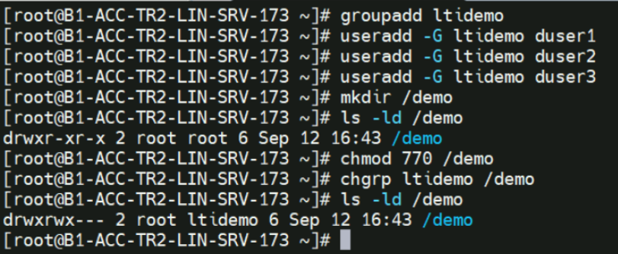

Removing access of duser2 for same directory.

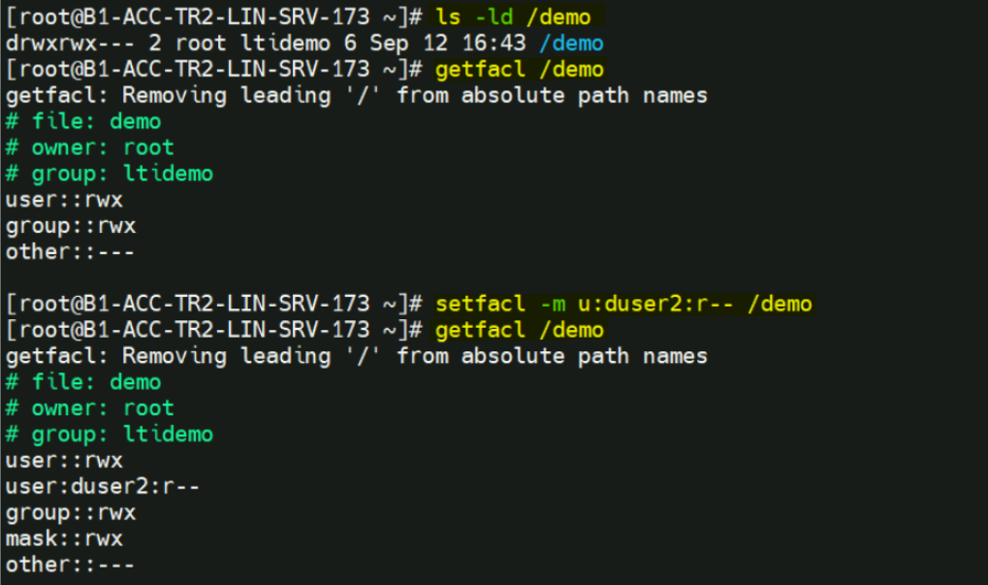

Giving read only access to directory:

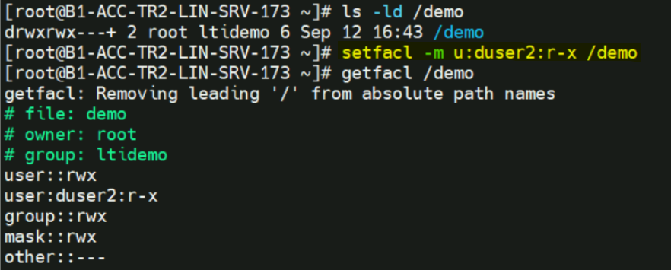

**Task 4 -** Display the following values using commands:

* Name of your linux system
* IP address of your system.
* Free and available RAM

Name of your linux system:

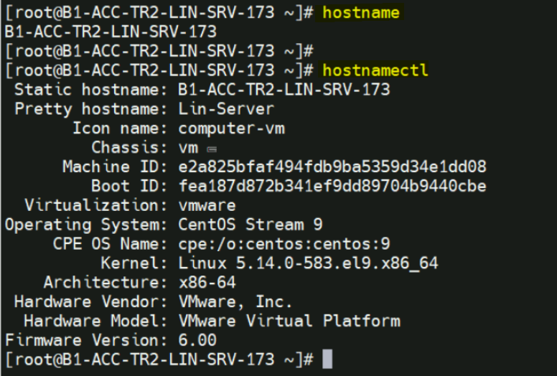

IP address of your system.

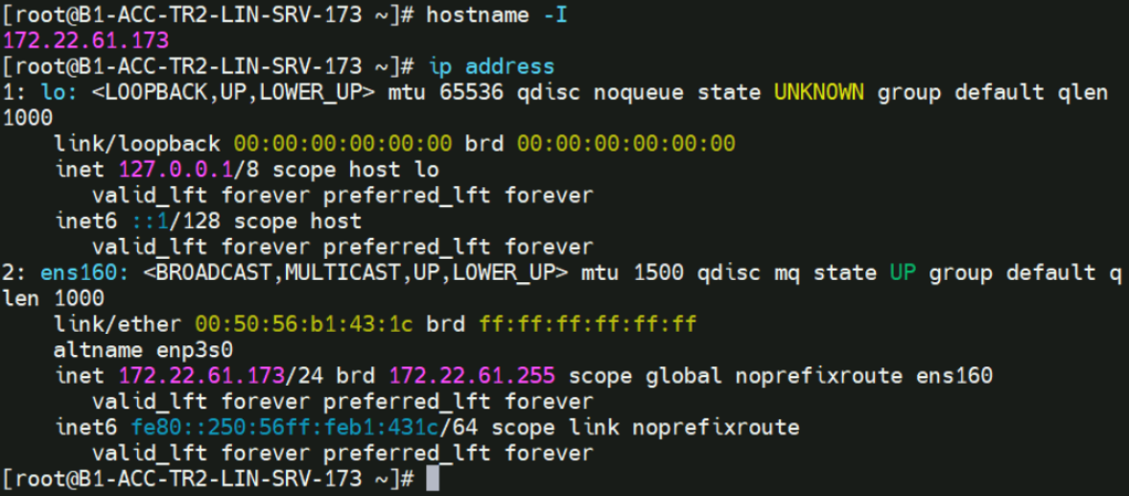

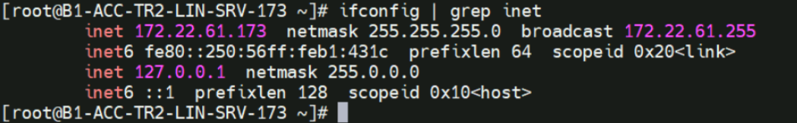

Free and available RAM:

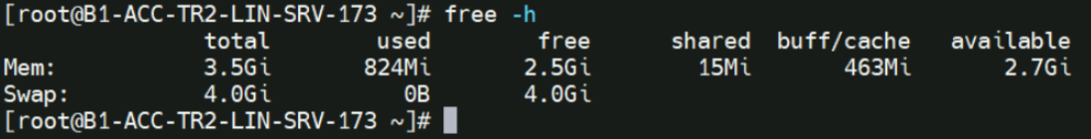

**Task 5 –** remove the RAID 0 from linux

Listing RAID details:

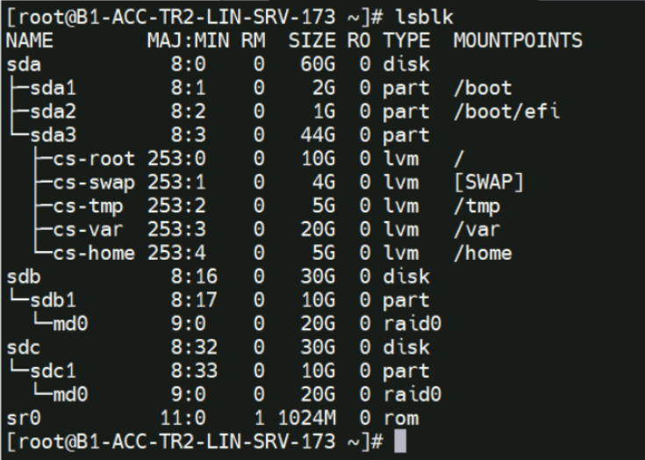

Listing details:

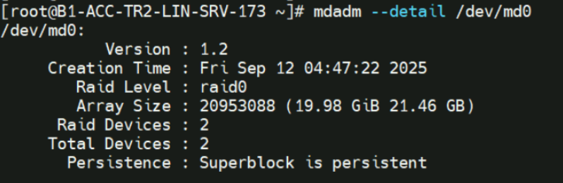

Unmount the mounted RAID partition:

# umount /raid0

Stopping the RAID:

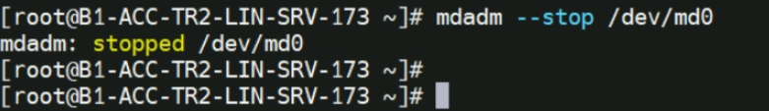

Removing the RAID:

# mdadm --remove /dev/md0

Run the following command:

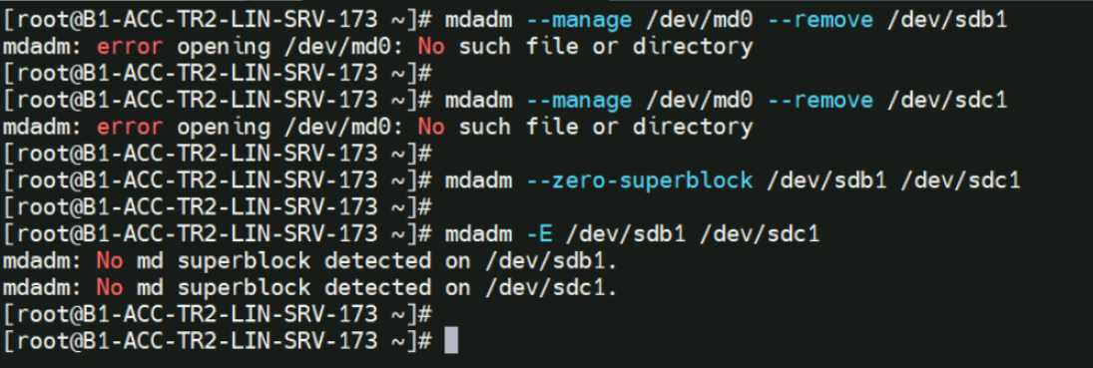

Verify:

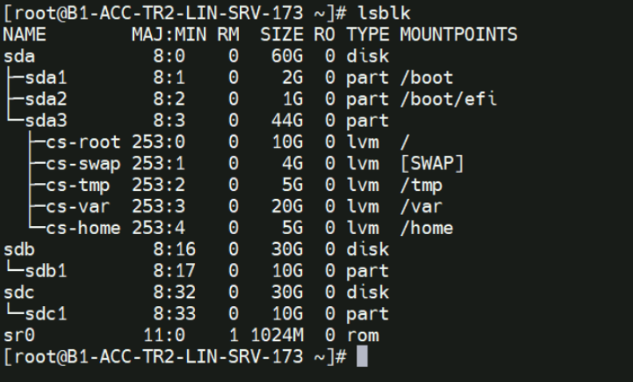

**Task 6** – Create 2 LVM using the /dev/sdb and /dev/sdc with EXT4 with 7GB LVM and XFS with 3GB LVM file system respectively. Add another 10GB and extend 2nd LVM from ~3GB to ~13GB and verify.

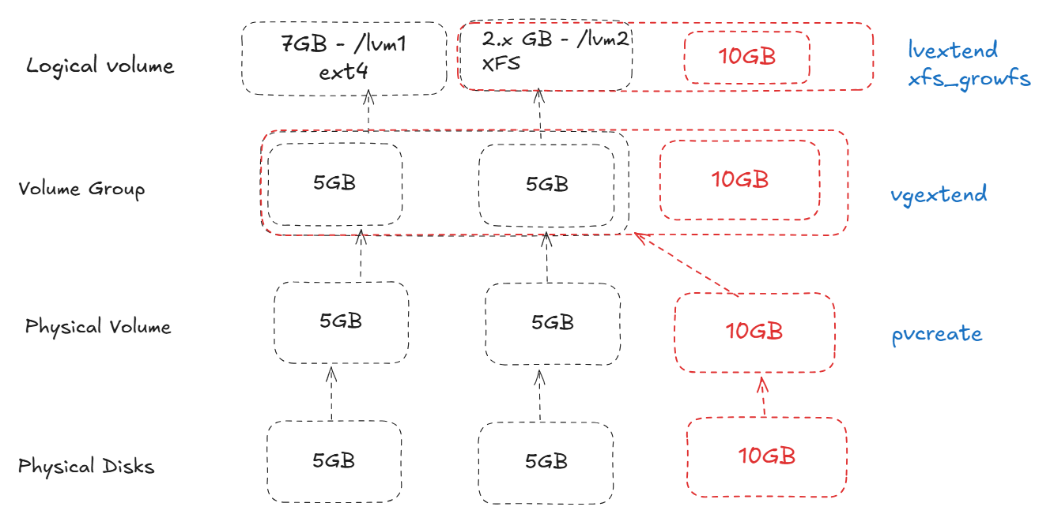

**Solution:**

Listing current status:

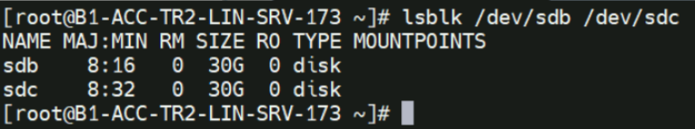

Creating 5-5GB partitions using /dev/sdb and /dev/sdc

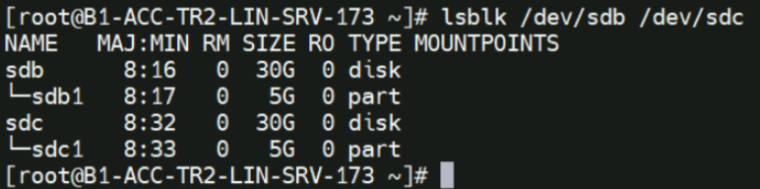

Creating physical volume:

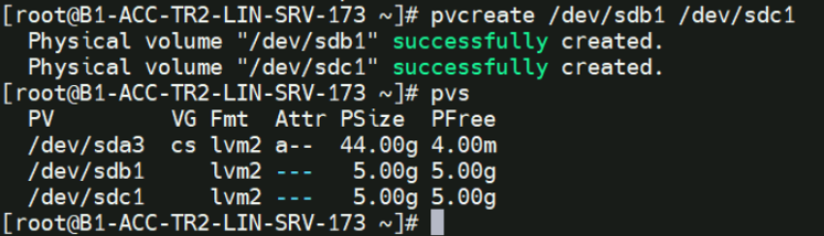

Creating volume group:

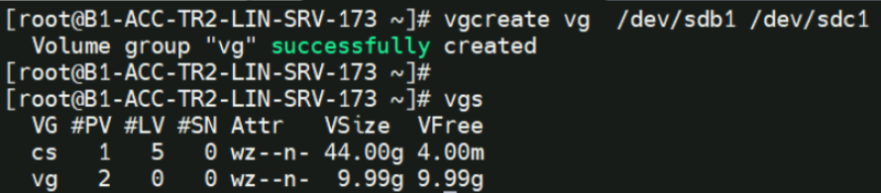

Creating logical volume:

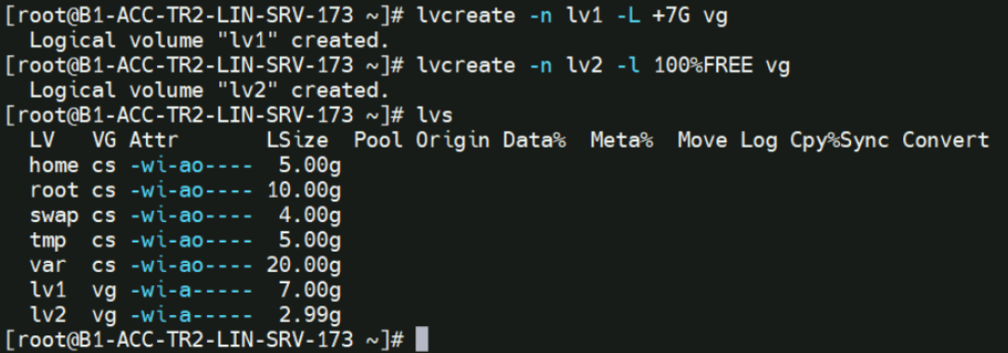

Creating a directories /lvm1 and /lvm2. Also, creating EXT4 partition for LV1.

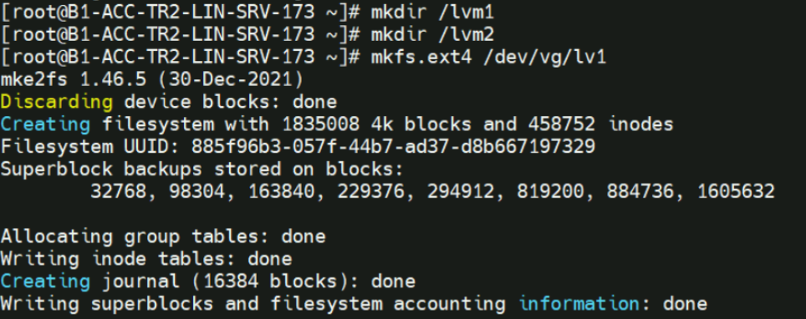

Creating XFS partition for LV2.

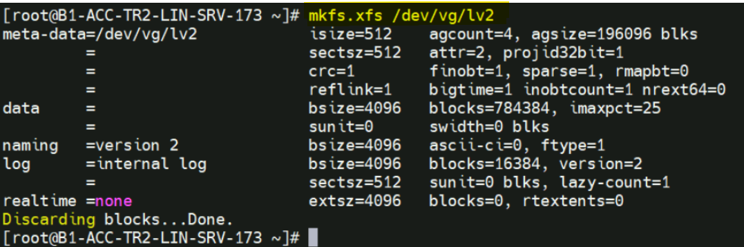

Mounting the partition:

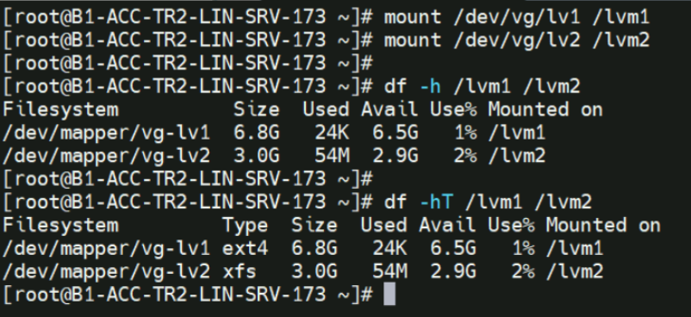

Extending the partition:

Creating 10 GB partition from /dev/sdc:

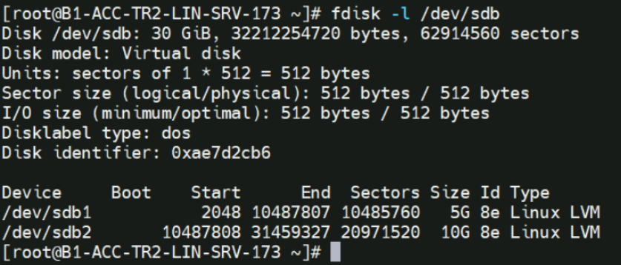

Creating PV:



Extending VG:

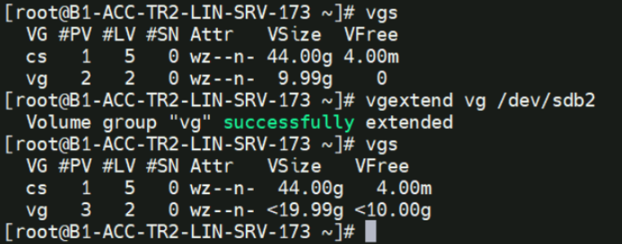

Extending LV (lv2):

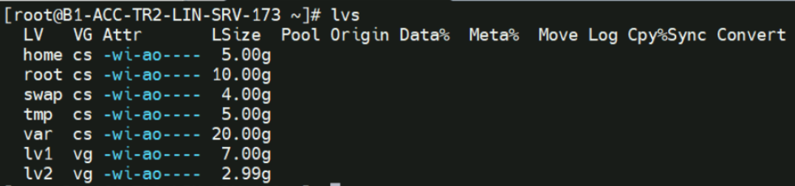

Extending the LV:

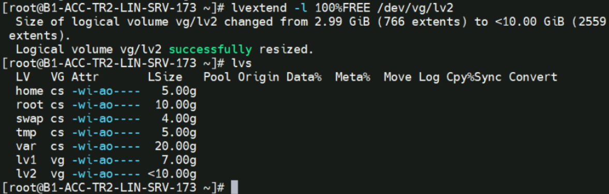

Checking the size – updated size isn’t available.

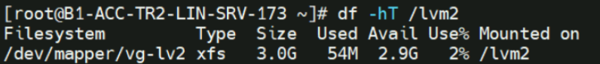

Resizing the current available:

